3.90: As in the previous problem, the horizontal distance x in terms of the angles is
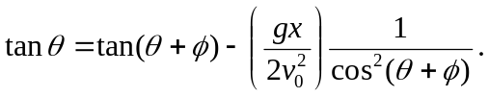
Denote the dimensionless quantity 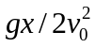 by 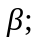 in this case
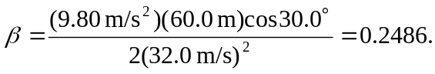
The above relation can then be written, on multiplying both sides by the product 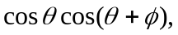
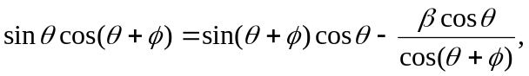
and so
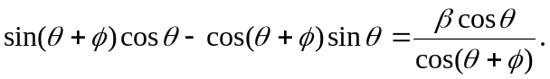

The term on the left is 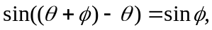 so the result of this combination is

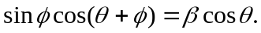

Although this can be done numerically (by iteration, trial-and-error, or other methods), the expansion 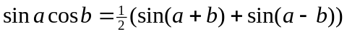 allows the angle to be isolated; specifically, then
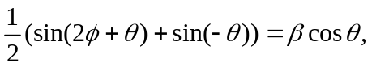
with the net result that
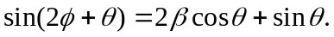
a) For 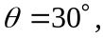 and 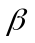 as found above, 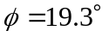 and the angle above the horizontal is 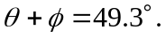 For level ground, using 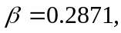 gives 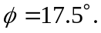 b) For 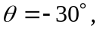 the same as with 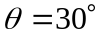 may be used 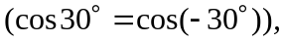 giving 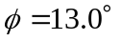 and 